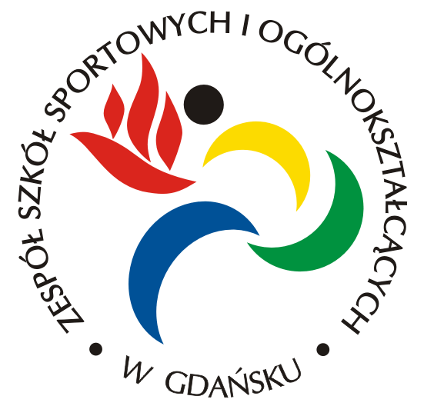
EUROPEAN ENTREPRENEURS’ WEEK
GDAŃSK - 21-26.05.2014
Day | Activity
Wednesday (21.05) | Arrival – the students will be picked up  by the host families from the airport.
Thursday (22.05) | 8.30 – meeting at school + the plan of the meeting  8.40 – headmistress’ speech  8.50 – 9.30  - a city presentation  - our school presentation  - a project presentation/ the schools presentations (our common Power Point presentation + students comments)  -the tour of the school +  the presentations of our students  (sport, dance, theatre, etc.) - a short show  10. 15 – 10.45 – break / snacks  - – 11.45  -work in international groups - get to know each other,  creativity, entrepreneurship  11.45-12.00 - break  12.00 – 12.50  a very short course of the Polish language + a competition  12.50 - 13.35 – lunch at school  13.40 – 15.00 – work in national groups  (training for the presentation of the business plan, preparing the karaoke singing  / coordinator meeting 1)  16.00- 17.00 – visiting the Old City with  a guide  --------------------------------------------------------------------------  17.15 – students will be picked up by the host families “Golden Gate” (1 group)  17.45 – from school (2 group)  18.00/18.30 – teachers’ meeting in the restaurant “Swojski Smak” ul.Heweliusza 25/27
Friday (23.05) | 8.30 – meeting at school  9.00 – 11.30 – a visit to a “Business Incubator” – presenting business plans by all the countries in front of the panel of experts  12.00 – coming back to school  12.00 –12.50 - summing up / students’ feedbacks  12.50 – 13.30 – lunch at school  13.40-14.10 -  “ Europe Quiz” - work in international groups  14.15- 15.30 – relaxation for students / coordinators meeting 2  15. 30 – 17.30 – a visit to Sopot  + a competition results
Saturday (24.05) | - – “A Sports Day” – meeting at school  9.15 – warming up  9.30 – 10.30  -individual sports training  10.30 – 11.15 – students’ impression +  a show  11.15 – 11.45 – break/snacks  11.45 – 13.00  Team games  13.00- 13.30 - lunch at school  13.30– a coordinators meeting 3 (as long as we need)  17.30 – a rehearsal for a Talent Show  (klub “Delfin”, Gdańsk, ul. Siennicka 5)  19.00 -24.00 - Talent Show  + kareoke singing + a party  (klub “Delfin”, Gdańsk, ul. Siennicka 5) | -athletics  -swimming  -judo  -Cheerleader dancing  Team games  - table tennis  - football  - volleyball  - basketball  18.30 – meeting in front of the Central Station
Sunday (25.05) | 9.30 – meeting in Gdańsk – Central Station  10.00 – 11.00 – a visit to a Solidarity Museum  11.00 – 13.00 – A History Rally  13.00–14.00 - lunch (KFC, MacDonald for students – at the Central Station)  15.00 – 17.00  visit to Gdynia+ evaluation
Monday (26.05) | Departure

