Unemployment
Number of unemployed in Finland
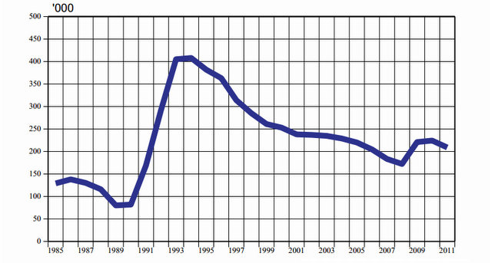
Unemployment rate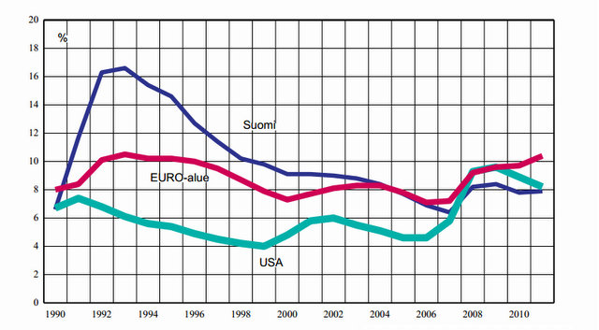source: statistics Finland

Standard of living
GNP per person in Finland
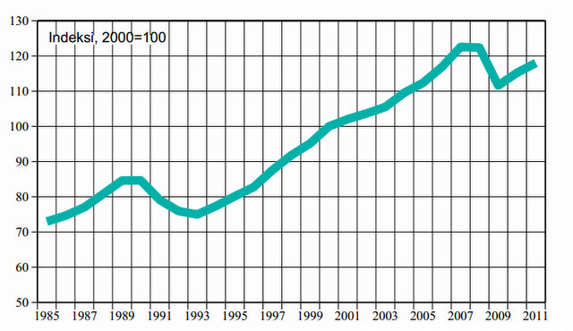
source: statistics Finland

- Finland is a country of stable income distribution.
- Standard of living in Finland rose between 1999 and 2008 almost 30% when using GNP per inhabitant.
- In Finland, differences in income are still quite small, working hours are the shortest in the world and there is more spare time than in the top GNP countries.

Foreign trade
Export and import
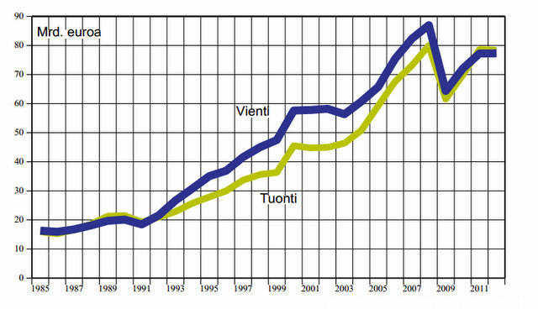

-Foreign trade has always been very important to Finland.

